***Certificate***

*This is to certify that Avii Ahuja of class 12 has successfully completed the project work for Informatics Practices, titled as “Quizzerio - A Quiz Game” for the Class 12 CBSE Practical Examination.*

_________________

**Ms. Narinder Kaur**

***Project Description***

This project is a quiz game which allows the user to take a default quiz, create a quiz, take a created quiz and delete a created quiz.

**Technologies Used**

* Front-End
  + Java (Netbeans)
* Back-End
  + MySQL

***Acknowledgement***

*For the successful completion of this project, I would like to express my deep gratitude towards my IP teacher Ms. Narinder Kaur for her continuous guidance and support throughout the tenure. Without her guidance and motivation, this project’s success would not have been possible.*

**Informatics Practices**

**Project**

**Quizzerio - A Quiz Game**

**By -** Avii Ahuja, Vibhak Golchha, Aryan Singh

***Avii Ahuja***

***Roll Number -***

***Menu***

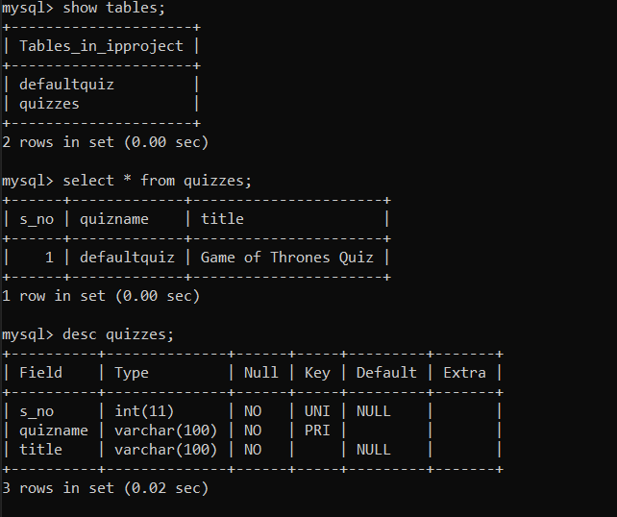

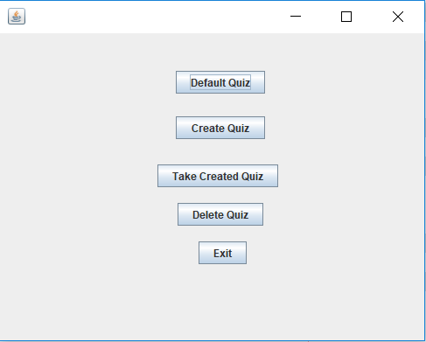

private void jButton1ActionPerformed(java.awt.event.ActionEvent evt) {

// TODO add your handling code here:

this.dispose();

new defaultQuiz().setVisible(true);

}

private void jButton5ActionPerformed(java.awt.event.ActionEvent evt) {

// TODO add your handling code here:

int a = JOptionPane.showConfirmDialog(this,"Are you sure you want to exit the game?","Ëxit Quiz Game",JOptionPane.YES_NO_OPTION);

if(a==0){

System.exit(0);

}

}

private void jButton2ActionPerformed(java.awt.event.ActionEvent evt) {

// TODO add your handling code here:

this.dispose();

new createQuiz().setVisible(true);

}

private void jButton3ActionPerformed(java.awt.event.ActionEvent evt) {

// TODO add your handling code here:

this.dispose();

new takeQuiz().setVisible(true);

}

private void jButton4ActionPerformed(java.awt.event.ActionEvent evt) {

// TODO add your handling code here:

this.dispose();

new deleteQuiz().setVisible(true);

}

***Default Quiz***

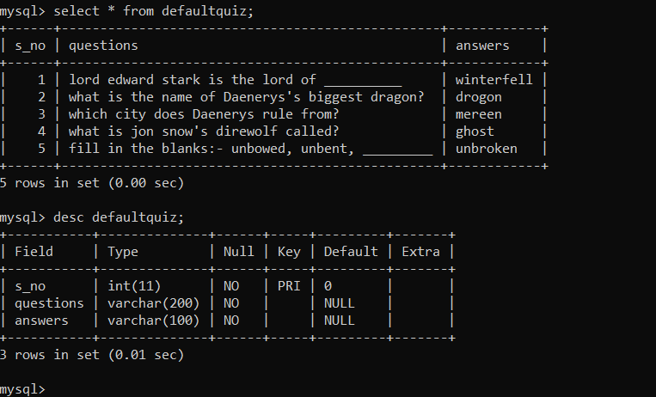

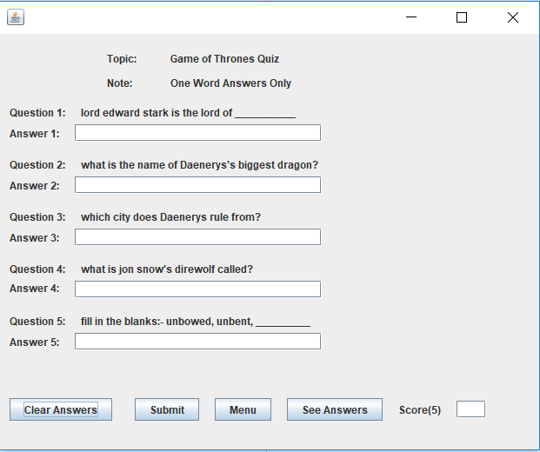

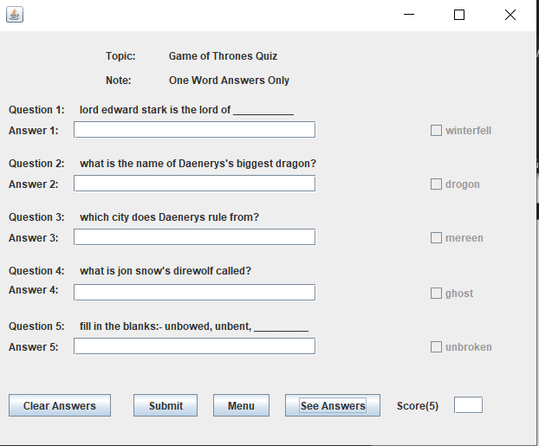

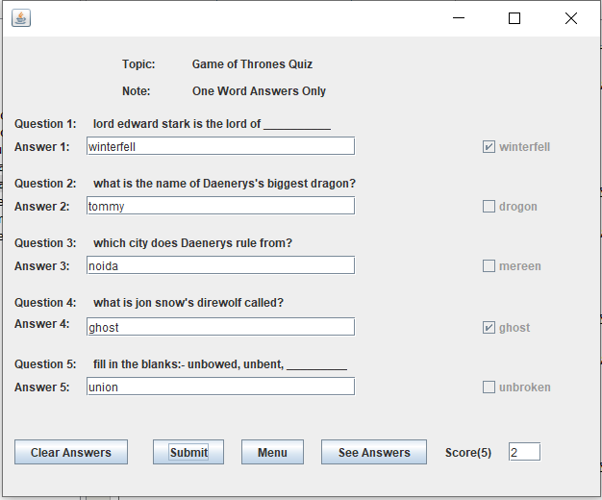

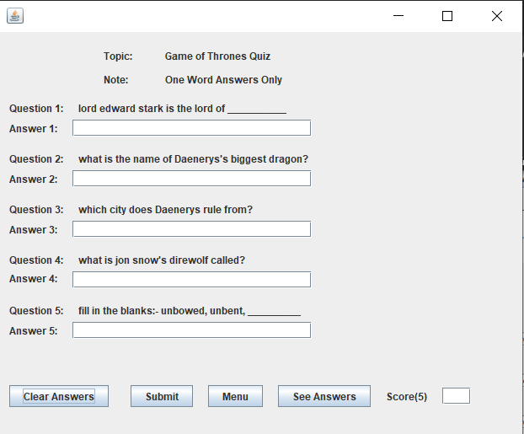

public defaultQuiz() {

initComponents();

try{

Class.forName("java.sql.DriverManager");

Connection con = (Connection) DriverManager.getConnection(

"jdbc:mysql://localhost:3306/ipproject","root","1234");

Statement s1 = (Statement) con.createStatement();

Statement s2 = (Statement) con.createStatement();

Statement s3 = (Statement) con.createStatement();

Statement s4 = (Statement) con.createStatement();

Statement s5 = (Statement) con.createStatement();

Statement s6 = (Statement) con.createStatement();

String query1 = "SELECT * FROM defaultquiz WHERE s_no=1";

String query2 = "SELECT * FROM defaultquiz WHERE s_no=2";

String query3 = "SELECT * FROM defaultquiz WHERE s_no=3";

String query4 = "SELECT * FROM defaultquiz WHERE s_no=4";

String query5 = "SELECT * FROM defaultquiz WHERE s_no=5";

String query6 = "SELECT * FROM quizzes WHERE s_no=1";

ResultSet rs1 = s1.executeQuery(query1);

rs1.next();

lbq1.setText(rs1.getString("questions"));

ResultSet rs2 = s2.executeQuery(query2);

rs2.next();

lbq2.setText(rs2.getString("questions"));

ResultSet rs3 = s3.executeQuery(query3);

rs3.next();

lbq3.setText(rs3.getString("questions"));

ResultSet rs4 = s4.executeQuery(query4);

rs4.next();

lbq4.setText(rs4.getString("questions"));

ResultSet rs5 = s5.executeQuery(query5);

rs5.next();

lbq5.setText(rs5.getString("questions"));

ResultSet rs6 = s6.executeQuery(query6);

rs6.next();

lbtopic.setText(rs6.getString("title"));

cb1.setVisible(false);

cb1.setEnabled(false);

cb2.setVisible(false);

cb2.setEnabled(false);

cb3.setVisible(false);

cb3.setEnabled(false);

cb4.setVisible(false);

cb4.setEnabled(false);

cb5.setVisible(false);

cb5.setEnabled(false);

}

catch (Exception e){

JOptionPane.showMessageDialog(this,e.getMessage());

}

}

private void tfa1ActionPerformed(java.awt.event.ActionEvent evt) {

// TODO add your handling code here:

}

private void tfa4ActionPerformed(java.awt.event.ActionEvent evt) {

// TODO add your handling code here:

}

private void tfa3ActionPerformed(java.awt.event.ActionEvent evt) {

// TODO add your handling code here:

}

private void tfa2ActionPerformed(java.awt.event.ActionEvent evt) {

// TODO add your handling code here:

}

private void tfa5ActionPerformed(java.awt.event.ActionEvent evt) {

// TODO add your handling code here:

}

private void jButton1ActionPerformed(java.awt.event.ActionEvent evt) {

// TODO add your handling code here:

cb1.setVisible(false);

cb2.setVisible(false);

cb3.setVisible(false);

cb5.setVisible(false);

cb4.setVisible(false);

cb1.setSelected(false);

cb2.setSelected(false);

cb3.setSelected(false);

cb4.setSelected(false);

cb5.setSelected(false);

tfa1.setText("");

tfa2.setText("");

tfa3.setText("");

tfa4.setText("");

tfa5.setText("");

tfscore.setText("");

}

private void jButton2ActionPerformed(java.awt.event.ActionEvent evt) {

// TODO add your handling code here:

cb1.setVisible(true);

cb2.setVisible(true);

cb3.setVisible(true);

cb5.setVisible(true);

cb4.setVisible(true);

int s=0;

try{

Class.forName("java.sql.DriverManager");

Connection con = (Connection) DriverManager.getConnection("jdbc:mysql://localhost:3306/ipproject","root","1234");

Statement s1 = (Statement) con.createStatement();

Statement s2 = (Statement) con.createStatement();

Statement s3 = (Statement) con.createStatement();

Statement s4 = (Statement) con.createStatement();

Statement s5 = (Statement) con.createStatement();

String query1 = "SELECT * FROM defaultquiz WHERE s_no=1";

String query2 = "SELECT * FROM defaultquiz WHERE s_no=2";

String query3 = "SELECT * FROM defaultquiz WHERE s_no=3";

String query4 = "SELECT * FROM defaultquiz WHERE s_no=4";

String query5 = "SELECT * FROM defaultquiz WHERE s_no=5";

ResultSet rs1 = s1.executeQuery(query1);

rs1.next();

String a1 = rs1.getString("answers");

cb1.setText(a1);

if(a1.equals(tfa1.getText())){

cb1.setSelected(true);

s++;

}

else cb1.setSelected(false);

ResultSet rs2 = s2.executeQuery(query2);

rs2.next();

String a2 = rs2.getString("answers");

cb2.setText(a2);

if(a2.equals(tfa2.getText())){

cb2.setSelected(true);

s++;

}

else cb2.setSelected(false);

ResultSet rs3 = s3.executeQuery(query3);

rs3.next();

String a3 = rs3.getString("answers");

cb3.setText(a3);

if(a3.equals(tfa3.getText())){

cb3.setSelected(true);

s++;

}

else cb3.setSelected(false);

ResultSet rs4 = s4.executeQuery(query4);

rs4.next();

String a4 = rs4.getString("answers");

cb4.setText(a4);

if(a4.equals(tfa4.getText())){

cb4.setSelected(true);

cb4.setText(a4);

s++;

}

else cb4.setSelected(false);

ResultSet rs5 = s5.executeQuery(query5);

rs5.next();

String a5 = rs5.getString("answers");

cb5.setText(a5);

if(a5.equals(tfa5.getText())){

cb5.setSelected(true);

s++;

}

else cb5.setSelected(false);

}

catch (Exception e){

JOptionPane.showMessageDialog(this,e.getMessage());

}

tfscore.setText(Integer.toString(s));

}

private void jButton3ActionPerformed(java.awt.event.ActionEvent evt) {

// TODO add your handling code here:

this.setVisible(false);

new menu().setVisible(true);

}

private void jButton4ActionPerformed(java.awt.event.ActionEvent evt) {

// TODO add your handling code here:

try{

Class.forName("java.sql.DriverManager");

Connection con = (Connection) DriverManager.getConnection("jdbc:mysql://localhost:3306/ipproject","root","1234");

Statement s1 = (Statement) con.createStatement();

Statement s2 = (Statement) con.createStatement();

Statement s3 = (Statement) con.createStatement();

Statement s4 = (Statement) con.createStatement();

Statement s5 = (Statement) con.createStatement();

String query1 = "SELECT * FROM defaultquiz WHERE s_no=1";

String query2 = "SELECT * FROM defaultquiz WHERE s_no=2";

String query3 = "SELECT * FROM defaultquiz WHERE s_no=3";

String query4 = "SELECT * FROM defaultquiz WHERE s_no=4";

String query5 = "SELECT * FROM defaultquiz WHERE s_no=5";

ResultSet rs1 = s1.executeQuery(query1);

rs1.next();

String a1 = rs1.getString("answers");

cb1.setText(a1);

cb1.setVisible(true);

cb1.setSelected(false);

ResultSet rs2 = s2.executeQuery(query2);

rs2.next();

String a2 = rs2.getString("answers");

cb2.setText(a2);

cb2.setVisible(true);

cb2.setSelected(false);

ResultSet rs3 = s3.executeQuery(query3);

rs3.next();

String a3 = rs3.getString("answers");

cb3.setText(a3);

cb3.setVisible(true);

cb3.setSelected(false);

ResultSet rs4 = s4.executeQuery(query4);

rs4.next();

String a4 = rs4.getString("answers");

cb4.setText(a4);

cb4.setVisible(true);

cb4.setSelected(false);

ResultSet rs5 = s5.executeQuery(query5);

rs5.next();

String a5 = rs5.getString("answers");

cb5.setText(a5);

cb5.setVisible(true);

cb5.setSelected(false);

}

catch (Exception e){

JOptionPane.showMessageDialog(this,e.getMessage());

}

}

***Create Quiz***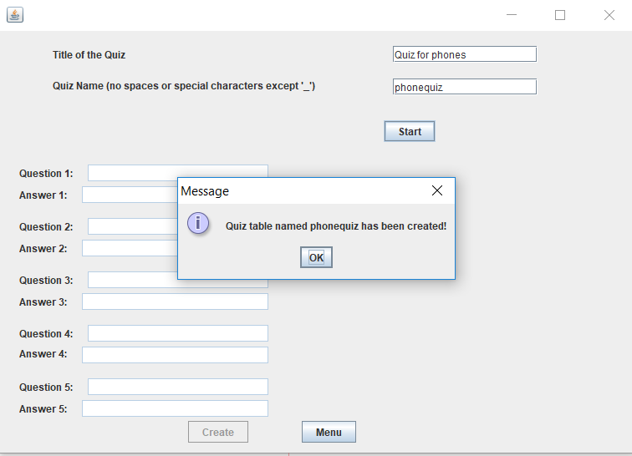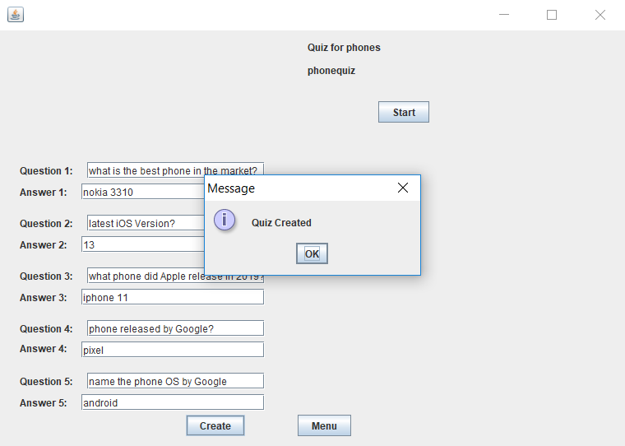

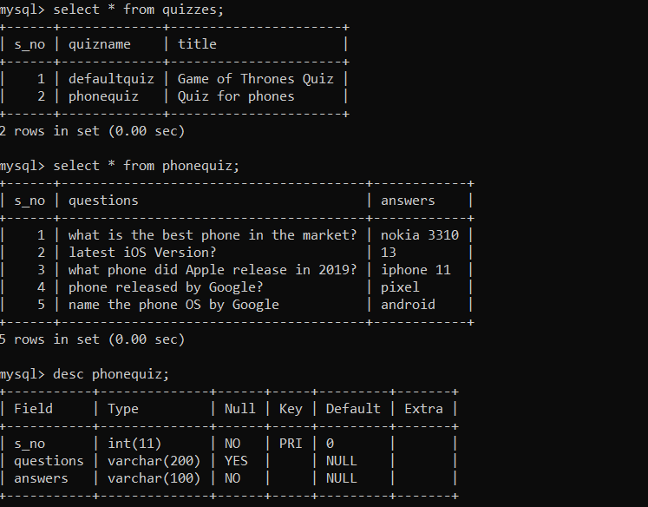

private void bstartActionPerformed(java.awt.event.ActionEvent evt) {

// TODO add your handling code here:

String title = tftitle.getText();

String name = tfname.getText();

try{

Class.forName("java.sql.DriverManager");

Connection con = (Connection) DriverManager.getConnection("jdbc:" +

"mysql://localhost:3306/ipproject",

"root","1234");

Statement s1 = (Statement) con.createStatement();

String query1 = "SELECT count(*) from quizzes";

ResultSet rs1 = s1.executeQuery(query1);

rs1.next();

int a = rs1.getInt(1);

a++;

Statement s2 = (Statement) con.createStatement();

String query2 = "INSERT INTO quizzes VALUES("+a+"," +

"'"+name+"','"+title+"');";

s2.executeUpdate(query2);

Statement s3 = (Statement) con.createStatement();

String query3 = "CREATE TABLE "+name+" (s_no int primary key," +

"questions" +

"varchar(200) not null,answers varchar(100) not null);";

s3.executeUpdate(query3);

JOptionPane.showMessageDialog(this,"Quiz table named "+name+

" has been created!");

tfq1.setEnabled(true);

tfa1.setEnabled(true);

tfq2.setEnabled(true);

tfa2.setEnabled(true);

tfq3.setEnabled(true);

tfa3.setEnabled(true);

tfq4.setEnabled(true);

tfa4.setEnabled(true);

tfq5.setEnabled(true);

tfa5.setEnabled(true);

bcreate.setEnabled(true);

jLabel1.setVisible(false);

jLabel2.setVisible(false);

tftitle.setVisible(false);

tfname.setVisible(false);

lbtitle.setVisible(true);

lbname.setVisible(true);

lbtitle.setText(title);

lbname.setText(name);

}

catch(Exception e){

JOptionPane.showMessageDialog(this,e.getMessage());

}

}

private void bcreateActionPerformed(java.awt.event.ActionEvent evt) {

// TODO add your handling code here:

String quiz = lbname.getText();

String q1,q2,q3,q4,q5,a1,a2,a3,a4,a5;

q1 = tfq1.getText();

a1 = tfa1.getText();

q2 = tfq2.getText();

a2 = tfa2.getText();

q3 = tfq3.getText();

a3 = tfa3.getText();

q4 = tfq4.getText();

a4 = tfa4.getText();

q5 = tfq5.getText();

a5 = tfa5.getText();

try{

Class.forName("java.sql.DriverManager");

Connection con = (Connection) DriverManager.getConnection("jdbc:" +

"mysql://localhost:3306/ipproject","root","1234");

Statement s1 = (Statement) con.createStatement();

String query1 = "INSERT INTO "+quiz+" VALUES(1,'"+q1+"'," +

"'"+a1+"');";

s1.executeUpdate(query1);

Statement s2 = (Statement) con.createStatement();

String query2 = "INSERT INTO "+quiz+" VALUES(2,'"+q2+"'," +

"'"+a2+"');";

s2.executeUpdate(query2);

Statement s3 = (Statement) con.createStatement();

String query3 = "INSERT INTO "+quiz+" VALUES(3,'"+q3+"'," +

"'"+a3+"');";

s3.executeUpdate(query3);

Statement s4 = (Statement) con.createStatement();

String query4 = "INSERT INTO "+quiz+" VALUES(4,'"+q4+"'," +

"'"+a4+"');";

s4.executeUpdate(query4);

Statement s5 = (Statement) con.createStatement();

String query5 = "INSERT INTO "+quiz+" VALUES(5,'"+q5+"'," +

"'"+a5+"');";

s5.executeUpdate(query5);

JOptionPane.showMessageDialog(this,"Quiz Created");

this.dispose();

new menu().setVisible(true);

}

catch(Exception e){

JOptionPane.showMessageDialog(this,e.getMessage());

}

}

***Take Quiz***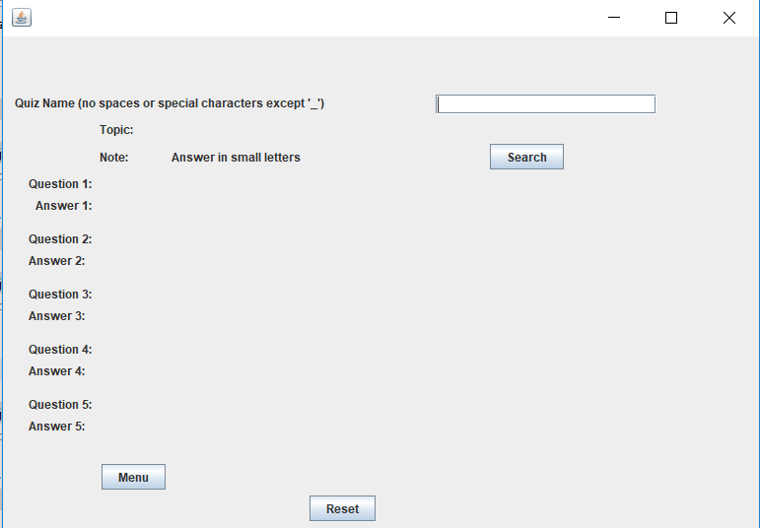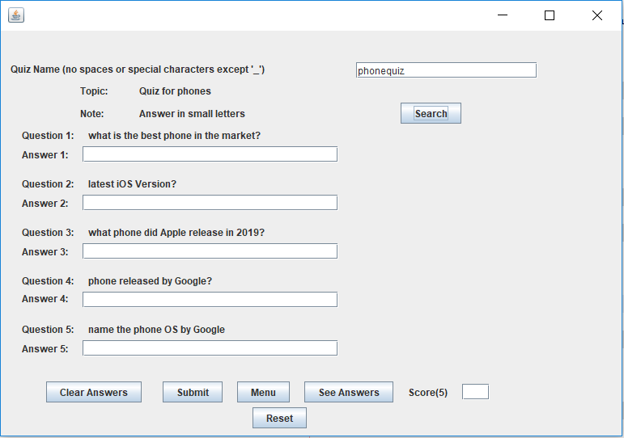

private void bsearchActionPerformed(java.awt.event.ActionEvent evt) {

// TODO add your handling code here:

String name = tfname.getText();

try{

Class.forName("java.sql.DriverManager");

Connection con = (Connection) DriverManager.getConnection("jdbc:mysql://localhost:3306/ipproject","root","1234");

Statement s1 = (Statement) con.createStatement();

Statement s2 = (Statement) con.createStatement();

Statement s3 = (Statement) con.createStatement();

Statement s4 = (Statement) con.createStatement();

Statement s5 = (Statement) con.createStatement();

Statement s6 = (Statement) con.createStatement();

String query1 = "SELECT * FROM "+name+" WHERE s_no=1;";

String query2 = "SELECT * FROM "+name+" WHERE s_no=2;";

String query3 = "SELECT * FROM "+name+" WHERE s_no=3;";

String query4 = "SELECT * FROM "+name+" WHERE s_no=4;";

String query5 = "SELECT * FROM "+name+" WHERE s_no=5;";

String query6 = "SELECT * FROM quizzes WHERE quizname='"+name+"';";

ResultSet rs1 = s1.executeQuery(query1);

rs1.next();

lbq1.setText(rs1.getString("questions"));

ResultSet rs2 = s2.executeQuery(query2);

rs2.next();

lbq2.setText(rs2.getString("questions"));

ResultSet rs3 = s3.executeQuery(query3);

rs3.next();

lbq3.setText(rs3.getString("questions"));

ResultSet rs4 = s4.executeQuery(query4);

rs4.next();

lbq4.setText(rs4.getString("questions"));

ResultSet rs5 = s5.executeQuery(query5);

rs5.next();

lbq5.setText(rs5.getString("questions"));

ResultSet rs6 = s6.executeQuery(query6);

rs6.next();

lbtopic.setText(rs6.getString("title"));

lbtopic.setVisible(true);

lbname.setText(name);

cb1.setVisible(false);

cb1.setEnabled(false);

cb2.setVisible(false);

cb2.setEnabled(false);

cb3.setVisible(false);

cb3.setEnabled(false);

cb4.setVisible(false);

cb4.setEnabled(false);

cb5.setVisible(false);

cb5.setEnabled(false);

lbq1.setVisible(true);

tfa1.setVisible(true);

lbq2.setVisible(true);

tfa2.setVisible(true);

lbq3.setVisible(true);

tfa3.setVisible(true);

lbq4.setVisible(true);

tfa4.setVisible(true);

lbq5.setVisible(true);

tfa5.setVisible(true);

bclear.setVisible(true);

bsubmit.setVisible(true);

banswer.setVisible(true);

lbscore.setVisible(true);

tfscore.setVisible(true);

} catch(Exception e){

JOptionPane.showMessageDialog(this,e.getMessage());

}

}

private void bclearActionPerformed(java.awt.event.ActionEvent evt) {

// TODO add your handling code here:

cb1.setVisible(false);

cb2.setVisible(false);

cb3.setVisible(false);

cb4.setVisible(false);

cb5.setVisible(false);

tfa1.setText("");

tfa2.setText("");

tfa3.setText("");

tfa4.setText("");

tfa5.setText("");

tfscore.setText("");

}

private void bsubmitActionPerformed(java.awt.event.ActionEvent evt) {

// TODO add your handling code here:

String name = lbname.getText();

cb1.setVisible(true);

cb2.setVisible(true);

cb3.setVisible(true);

cb4.setVisible(true);

cb5.setVisible(true);

int s=0;

try{

Class.forName("java.sql.DriverManager");

Connection con = (Connection) DriverManager.getConnection("jdbc:mysql://localhost:3306/ipproject","root","1234");

Statement s1 = (Statement) con.createStatement();

Statement s2 = (Statement) con.createStatement();

Statement s3 = (Statement) con.createStatement();

Statement s4 = (Statement) con.createStatement();

Statement s5 = (Statement) con.createStatement();

String query1 = "SELECT * FROM "+name+" WHERE s_no=1";

String query2 = "SELECT * FROM "+name+" WHERE s_no=2";

String query3 = "SELECT * FROM "+name+" WHERE s_no=3";

String query4 = "SELECT * FROM "+name+" WHERE s_no=4";

String query5 = "SELECT * FROM "+name+" WHERE s_no=5";

ResultSet rs1 = s1.executeQuery(query1);

rs1.next();

String a1 = rs1.getString("answer");

cb1.setText(a1);

if(a1.equals(tfa1.getText())){

cb1.setSelected(true);

s++;

}

ResultSet rs2 = s2.executeQuery(query2);

rs2.next();

String a2 = rs2.getString("answer");

cb2.setText(a2);

if(a2.equals(tfa2.getText())){

cb2.setSelected(true);

s++;

}

ResultSet rs3 = s3.executeQuery(query3);

rs3.next();

String a3 = rs3.getString("answer");

cb3.setText(a3);

if(a3.equals(tfa3.getText())){

cb3.setSelected(true);

s++;

}

ResultSet rs4 = s4.executeQuery(query4);

rs4.next();

String a4 = rs4.getString("answer");

cb4.setText(a4);

if(a4.equals(tfa4.getText())){

cb4.setSelected(true);

cb4.setText(a4);

s++;

}

ResultSet rs5 = s5.executeQuery(query5);

rs5.next();

String a5 = rs5.getString("answer");

cb5.setText(a5);

if(a5.equals(tfa5.getText())){

cb5.setSelected(true);

s++;

}

} catch (Exception e){

JOptionPane.showMessageDialog(this,e.getMessage());

}

tfscore.setText(Integer.toString(s));

}

private void bmenuActionPerformed(java.awt.event.ActionEvent evt) {

// TODO add your handling code here:

this.setVisible(false);

new menu().setVisible(true);

}

private void banswerActionPerformed(java.awt.event.ActionEvent evt) {

// TODO add your handling code here:

String name = lbname.getText();

try{

Class.forName("java.sql.DriverManager");

Connection con = (Connection) DriverManager.getConnection("jdbc:mysql://localhost:3306/ipproject","root","1234");

Statement s1 = (Statement) con.createStatement();

Statement s2 = (Statement) con.createStatement();

Statement s3 = (Statement) con.createStatement();

Statement s4 = (Statement) con.createStatement();

Statement s5 = (Statement) con.createStatement();

String query1 = "SELECT * FROM "+name+" WHERE s_no=1";

String query2 = "SELECT * FROM "+name+" WHERE s_no=2";

String query3 = "SELECT * FROM "+name+" WHERE s_no=3";

String query4 = "SELECT * FROM "+name+" WHERE s_no=4";

String query5 = "SELECT * FROM "+name+" WHERE s_no=5";

ResultSet rs1 = s1.executeQuery(query1);

rs1.next();

String a1 = rs1.getString("answers");

cb1.setText(a1);

cb1.setVisible(true);

cb1.setSelected(false);

ResultSet rs2 = s2.executeQuery(query2);

rs2.next();

String a2 = rs2.getString("answers");

cb2.setText(a2);

cb2.setVisible(true);

cb2.setSelected(false);

ResultSet rs3 = s3.executeQuery(query3);

rs3.next();

String a3 = rs3.getString("answers");

cb3.setText(a3);

cb3.setVisible(true);

cb3.setSelected(false);

ResultSet rs4 = s4.executeQuery(query4);

rs4.next();

String a4 = rs4.getString("answers");

cb4.setText(a4);

cb4.setVisible(true);

cb4.setSelected(false);

ResultSet rs5 = s5.executeQuery(query5);

rs5.next();

String a5 = rs5.getString("answers");

cb5.setText(a5);

cb5.setVisible(true);

cb5.setSelected(false);

} catch (Exception e){

JOptionPane.showMessageDialog(this,e.getMessage());

}

}

***Delete Quiz***

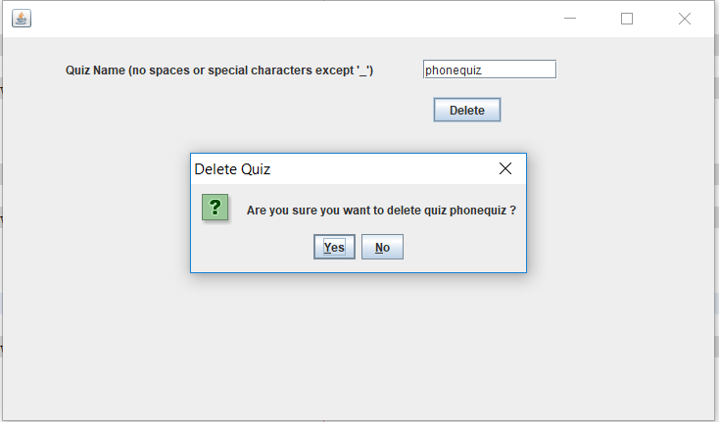

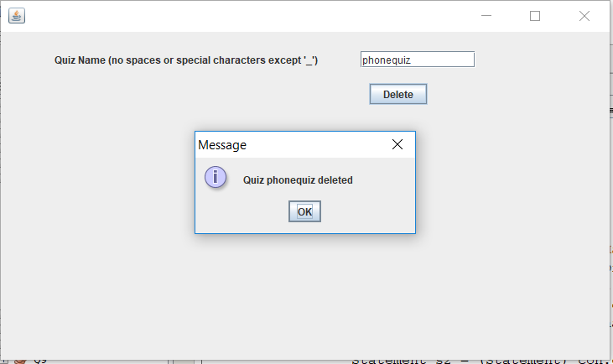

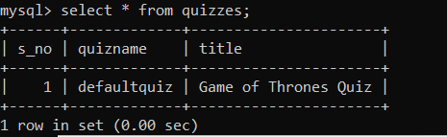

private void jButton1ActionPerformed(java.awt.event.ActionEvent evt) {

// TODO add your handling code here:

String name;

name = tfname.getText();

if(name.equals("defaultquiz")){

JOptionPane.showMessageDialog(this, "Cannot delete the " +

"default quiz");

this.dispose();

new menu().setVisible(true);

}

else{

try{

Class.forName("java.sql.DriverManager");

Connection con = (Connection) DriverManager.getConnection(

"jdbc:mysql://localhost:3306/ipproject","root","1234");

Statement s1 = (Statement) con.createStatement();

String query1 = "DROP TABLE "+name+";";

Statement s2 = (Statement) con.createStatement();

String query2 = "DELETE FROM quizzes where quizname='"+name+"';";

int a = JOptionPane.showConfirmDialog(this,"Are you" +

" sure you want to delete quiz " + name +

" ?","Delete Quiz",JOptionPane.YES_NO_OPTION);

if(a==0){

s1.executeUpdate(query1);

s2.executeUpdate(query2);

JOptionPane.showMessageDialog(this, "Quiz "+name+" deleted");

}

}

catch(Exception e){

JOptionPane.showMessageDialog(this,e.getMessage());

}

}

}

private void jButton2ActionPerformed(java.awt.event.ActionEvent evt) {

// TODO add your handling code here:

this.dispose();

new menu().setVisible(true);

}